**College Management System**

Description:

This Project, uses SQL to create a database, and store the values, and uses GUI(Swing) to provide user interface.

There are two databases being used, one for all the available users, and another to store student details like name, roll number, gpa, attendance, age, department.

There are three possible users, namely : admin, teacher, student.

The admin has the power to act as a teacher as well as a student, and ONLY the admin can add new login details to the login database.

The teacher, can perform a plethora of operations such as : Adding new student details, Updating old student details, Viewing a students details, Deleting a students details. Each operation does as the name suggests, and stores the inputted student details into the student database.

The student user, can only view his/her details.

The GUI aspect of this project, uses mainly frames, text-fields, labels, buttons, drop-down menu, pop up dialogs.

If we try logging in as a non existing user, we get a pop-up dialog saying the user doesn’t exist, if we enter a wrong password/username, we get an error message in the pop-up dialog.

Java Features Used:

* Swing
* JDBC
* Inheritance

Class Diagram:

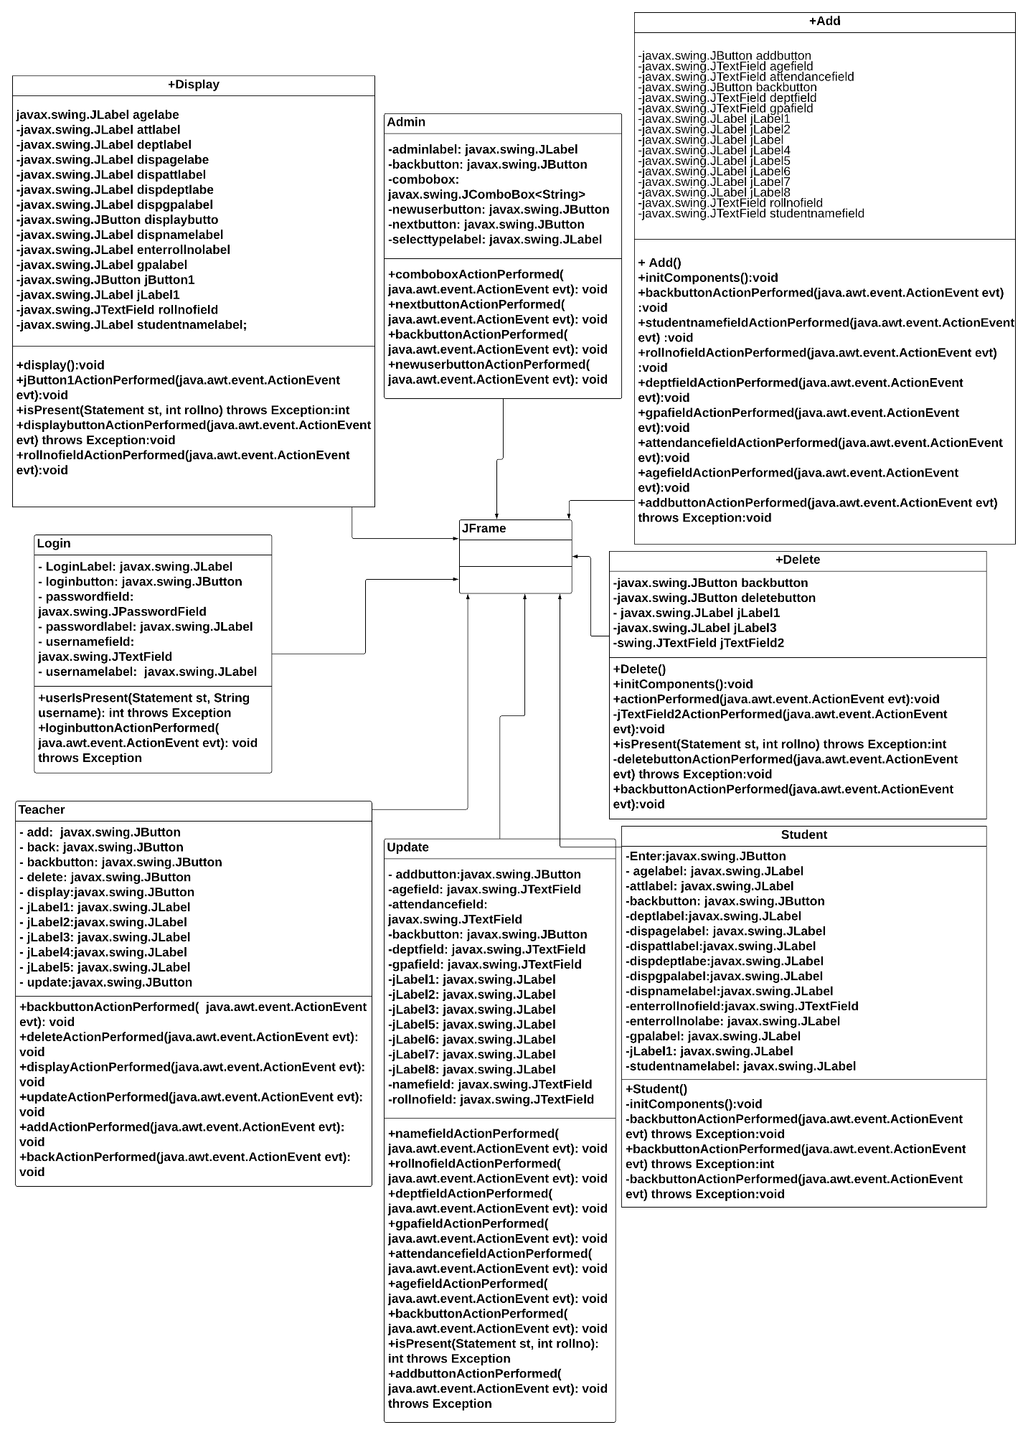

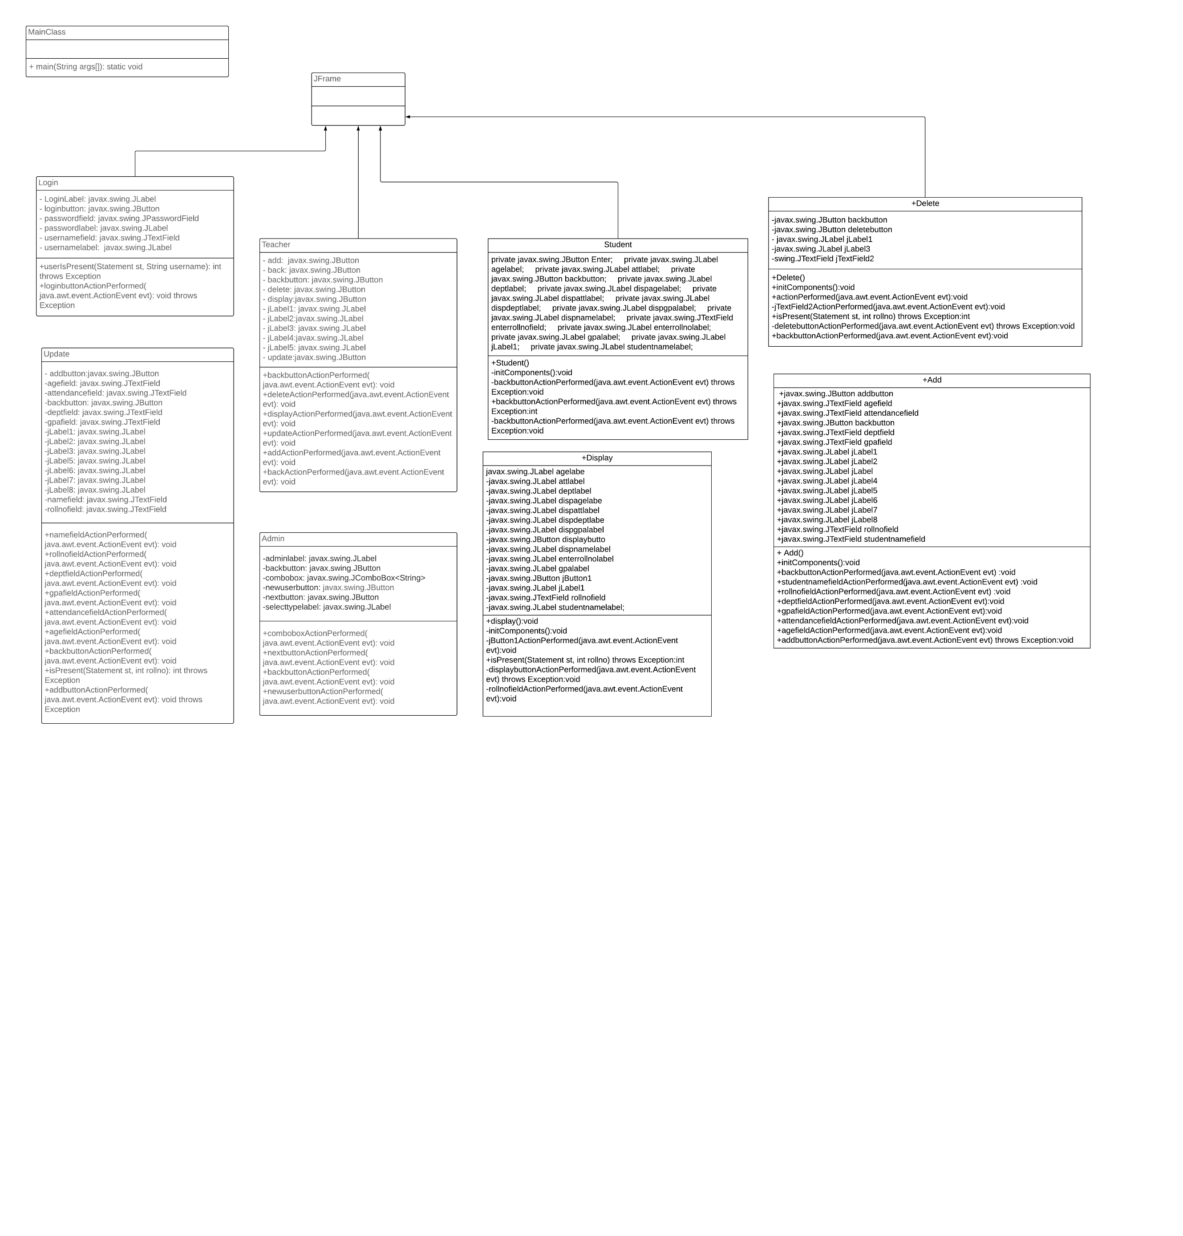

SQL Tables:

1. Student database:

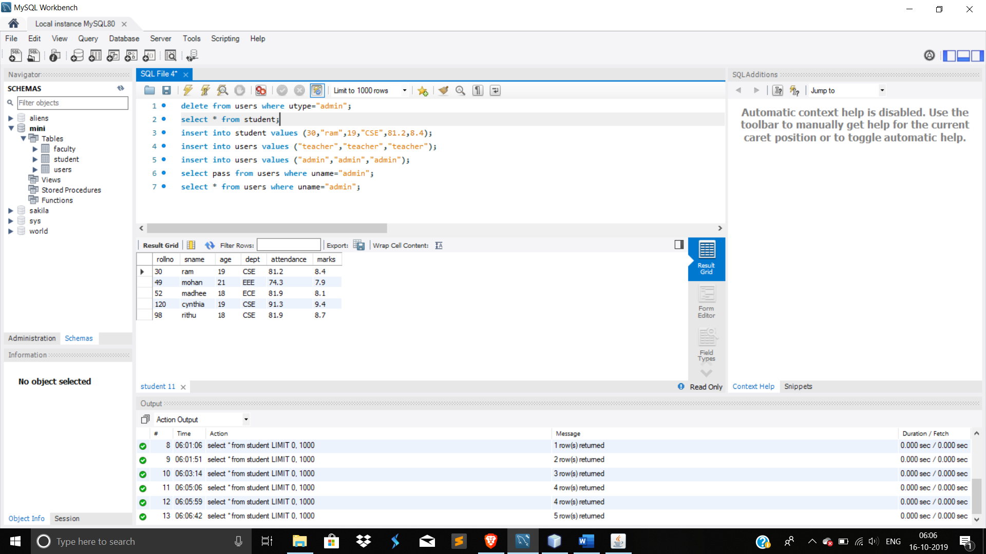

1. Users database:

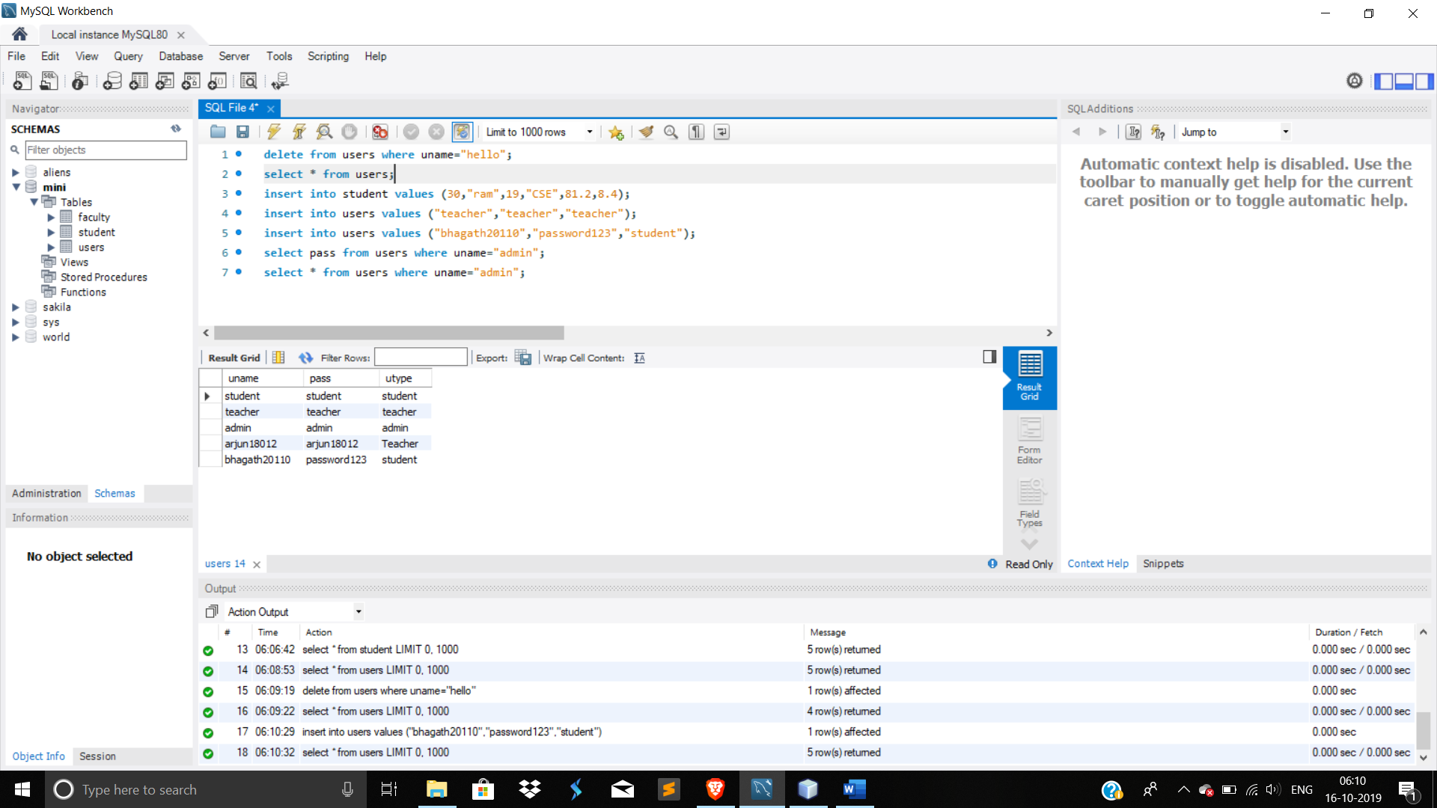

Output:

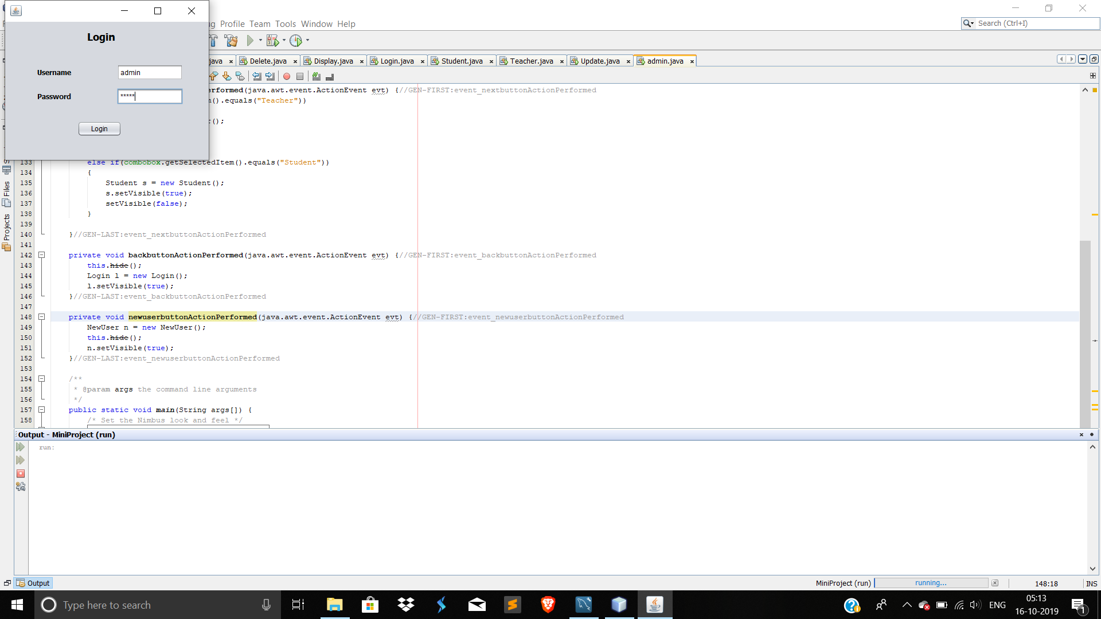 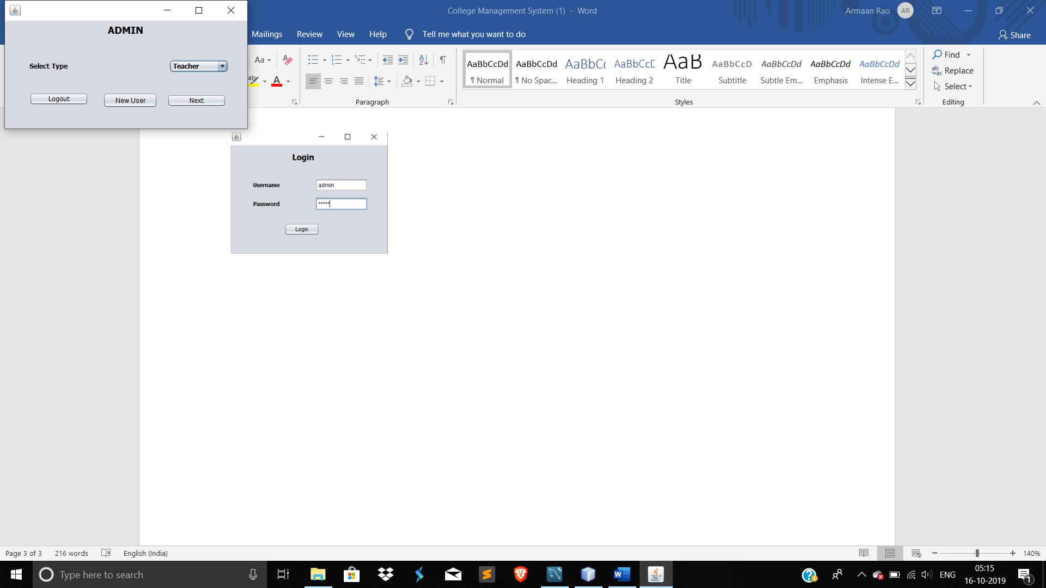

1. Loging in as an admin.

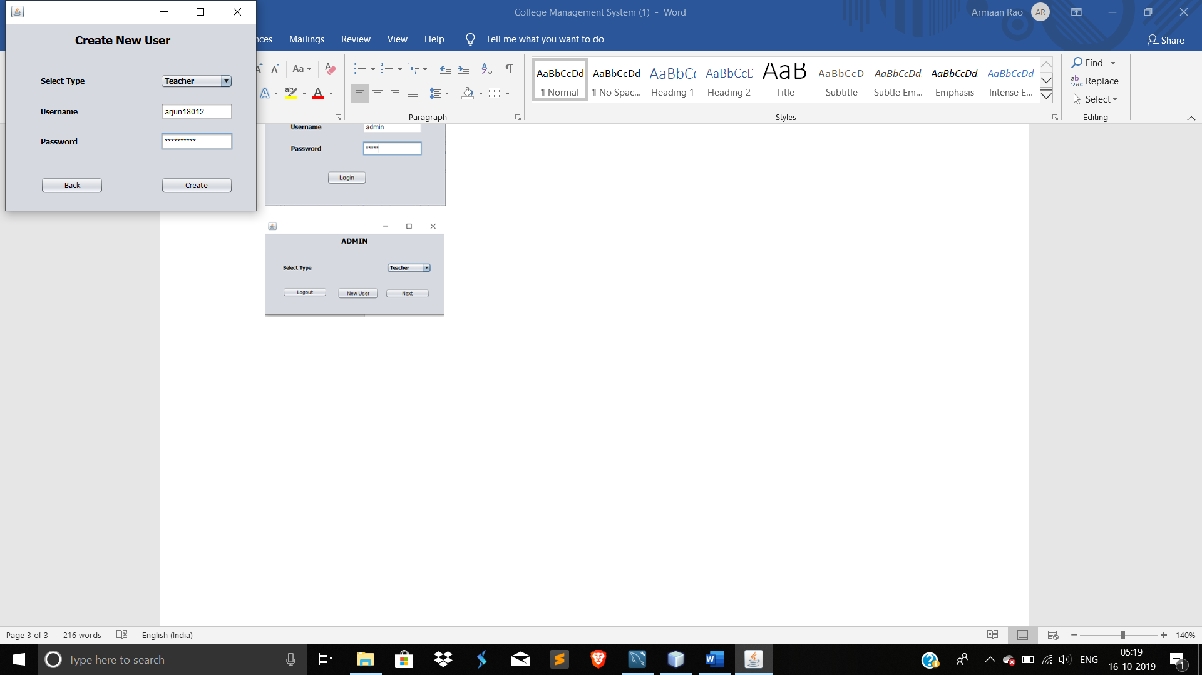 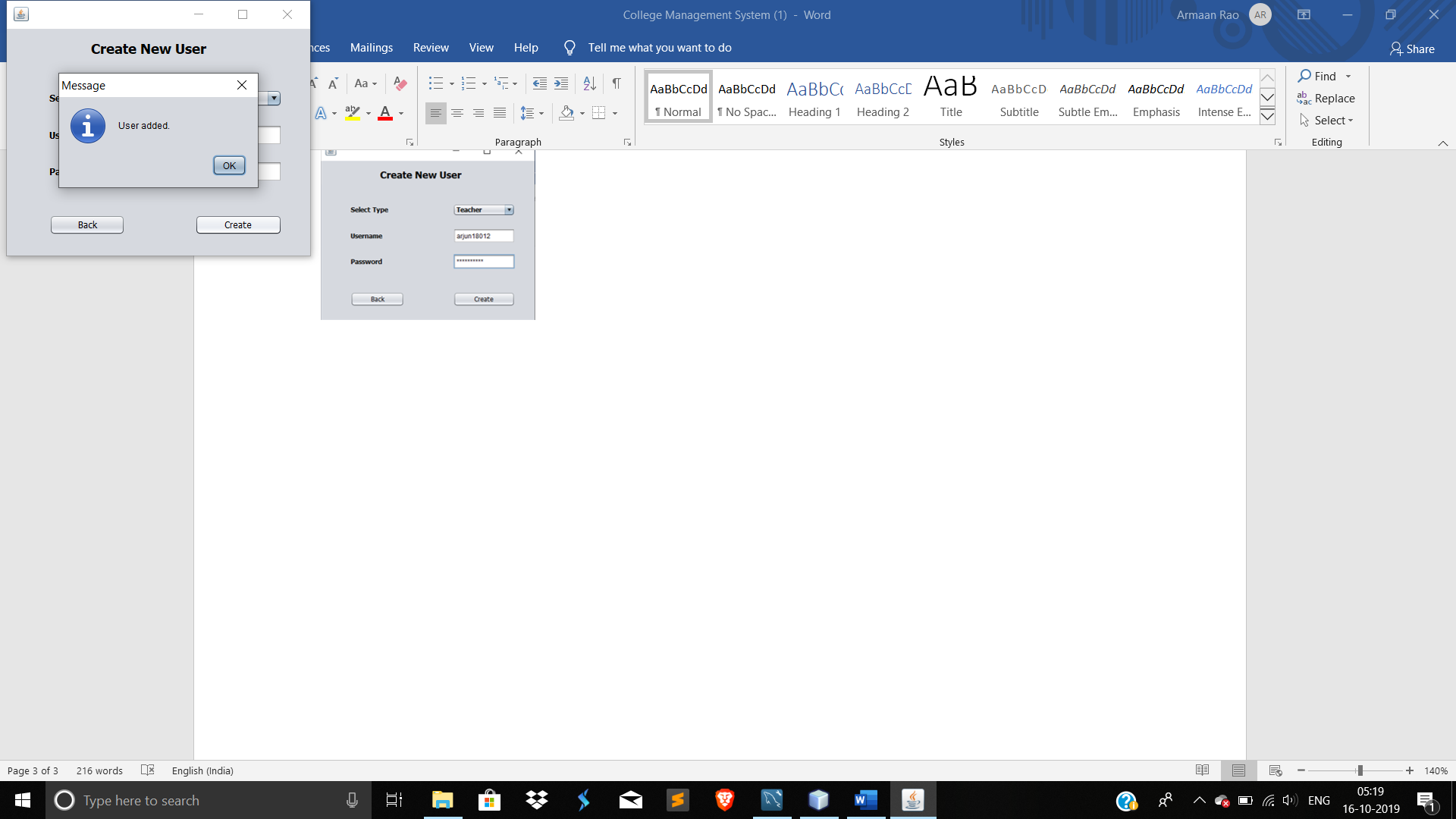

1. Creating a new user of type teacher.

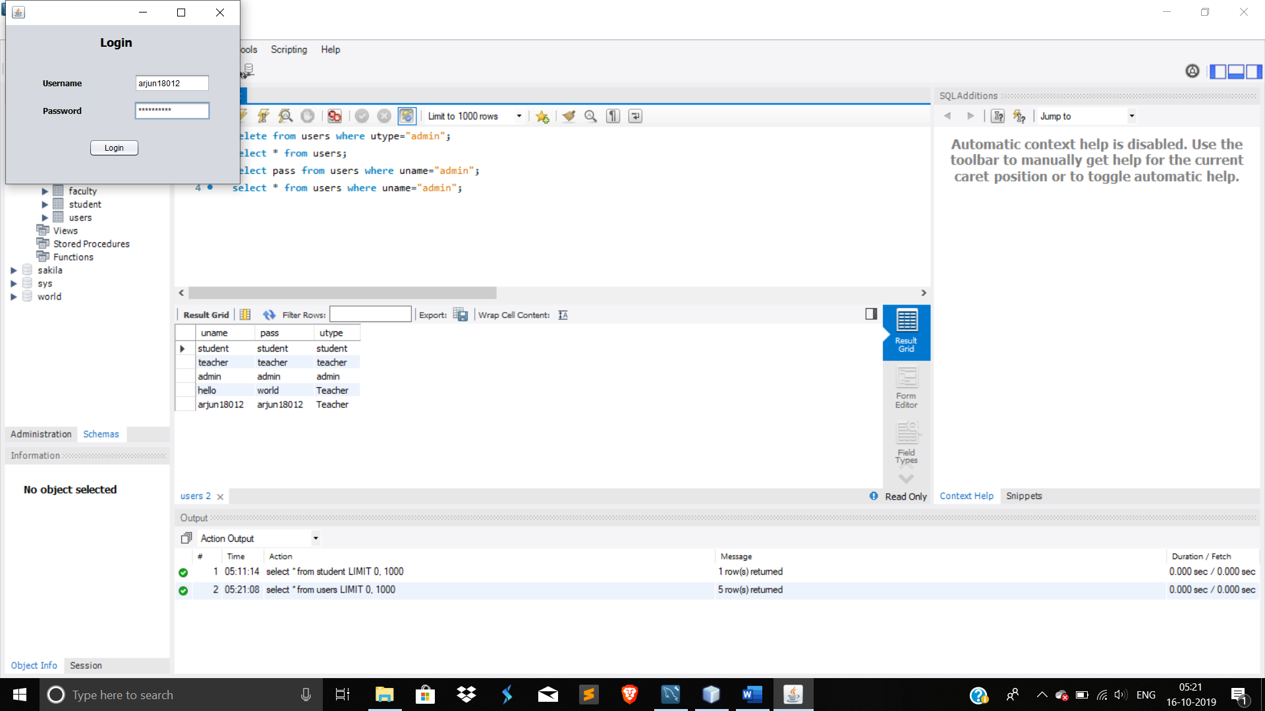 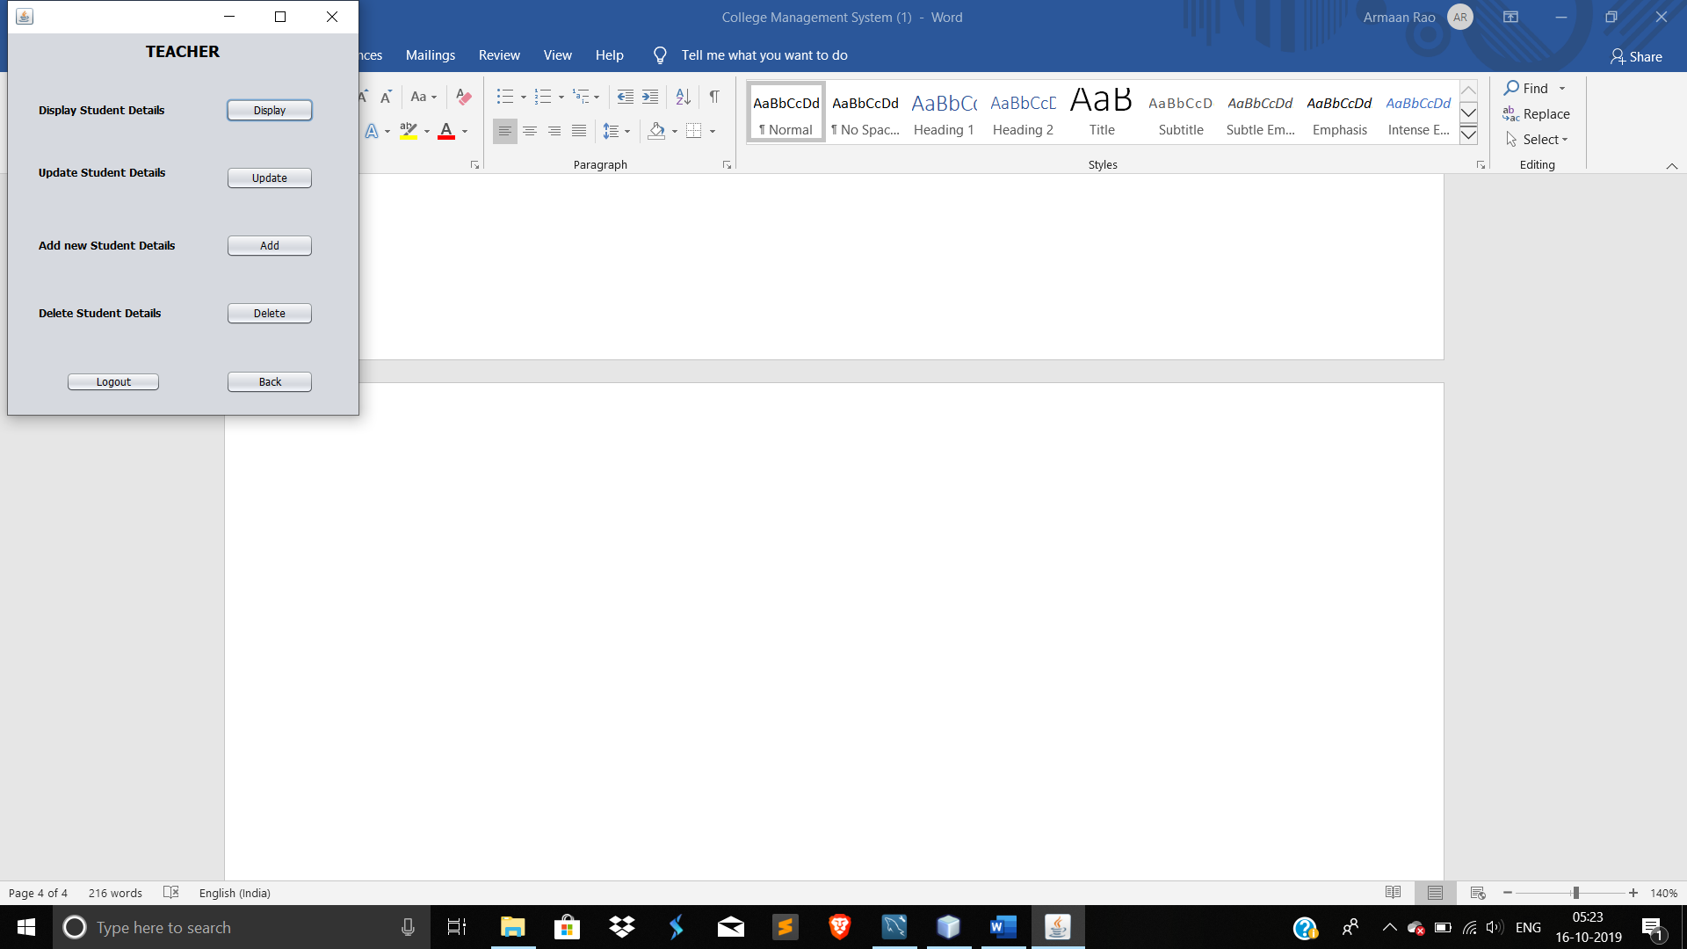

1. Loging in as a teacher.

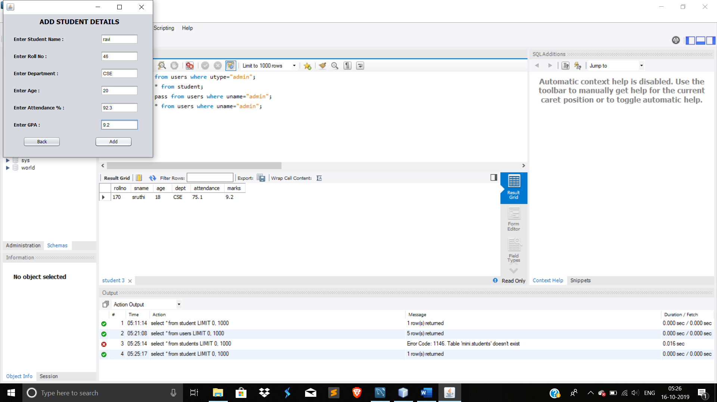 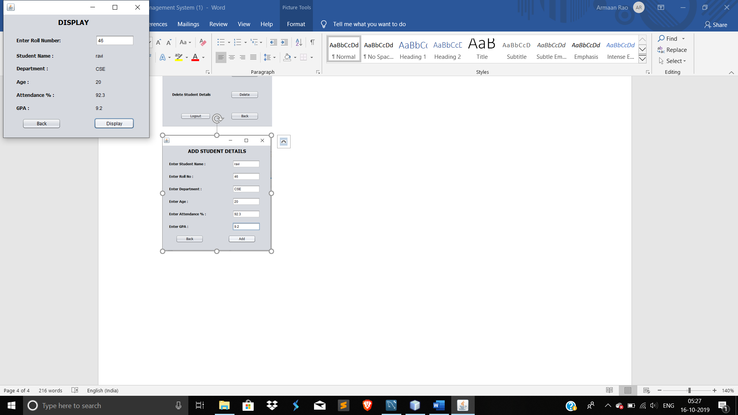

1. Adding a new student to the database.
2. Displaying a student’s details from the database using roll number.

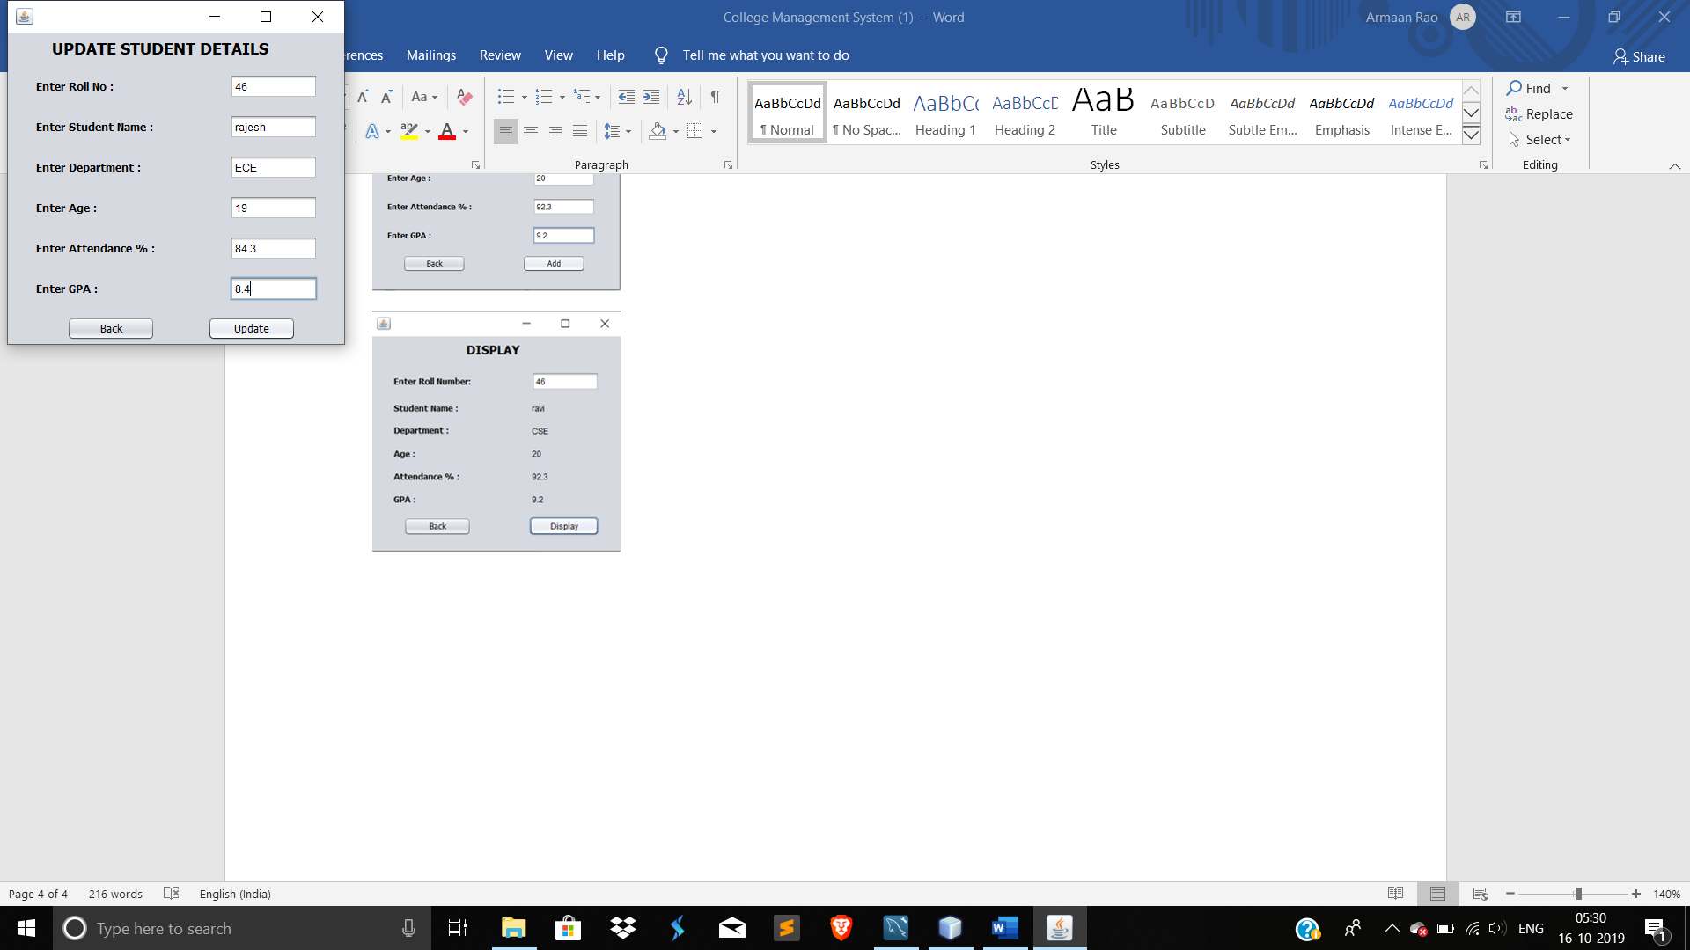 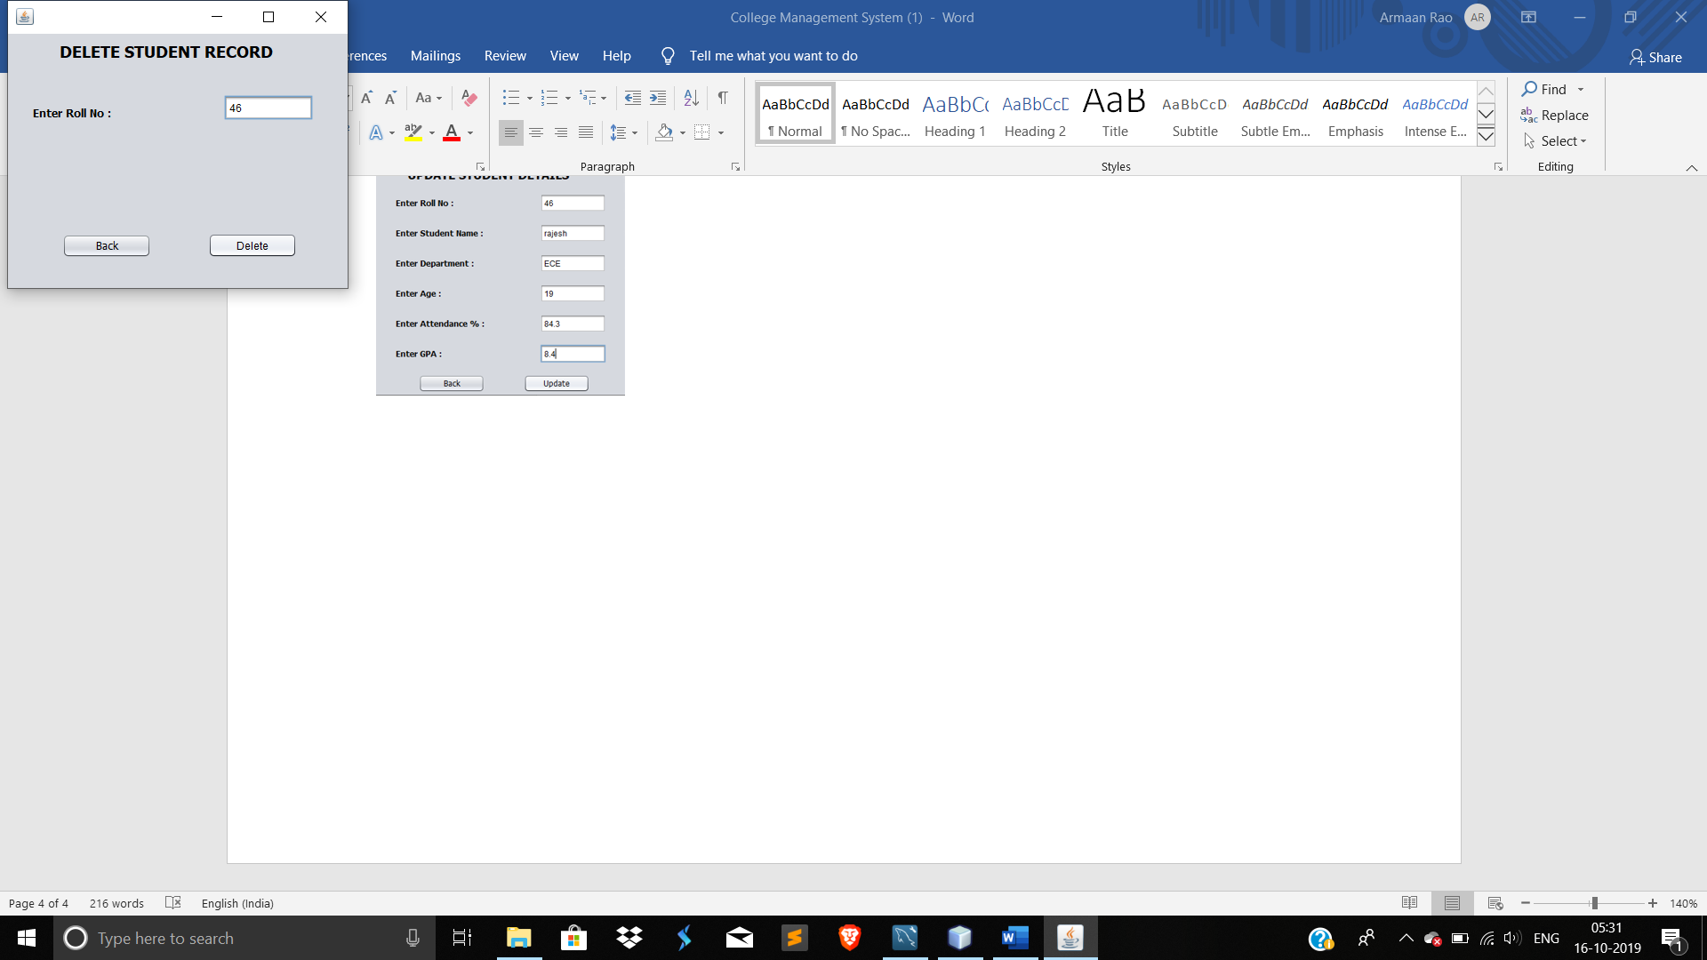

1. Updating and Existing student’s details using roll number.
2. Deleting an Existing student’s details using roll number.

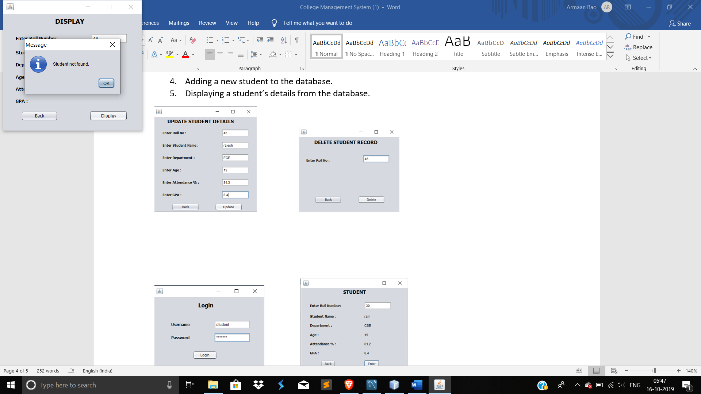 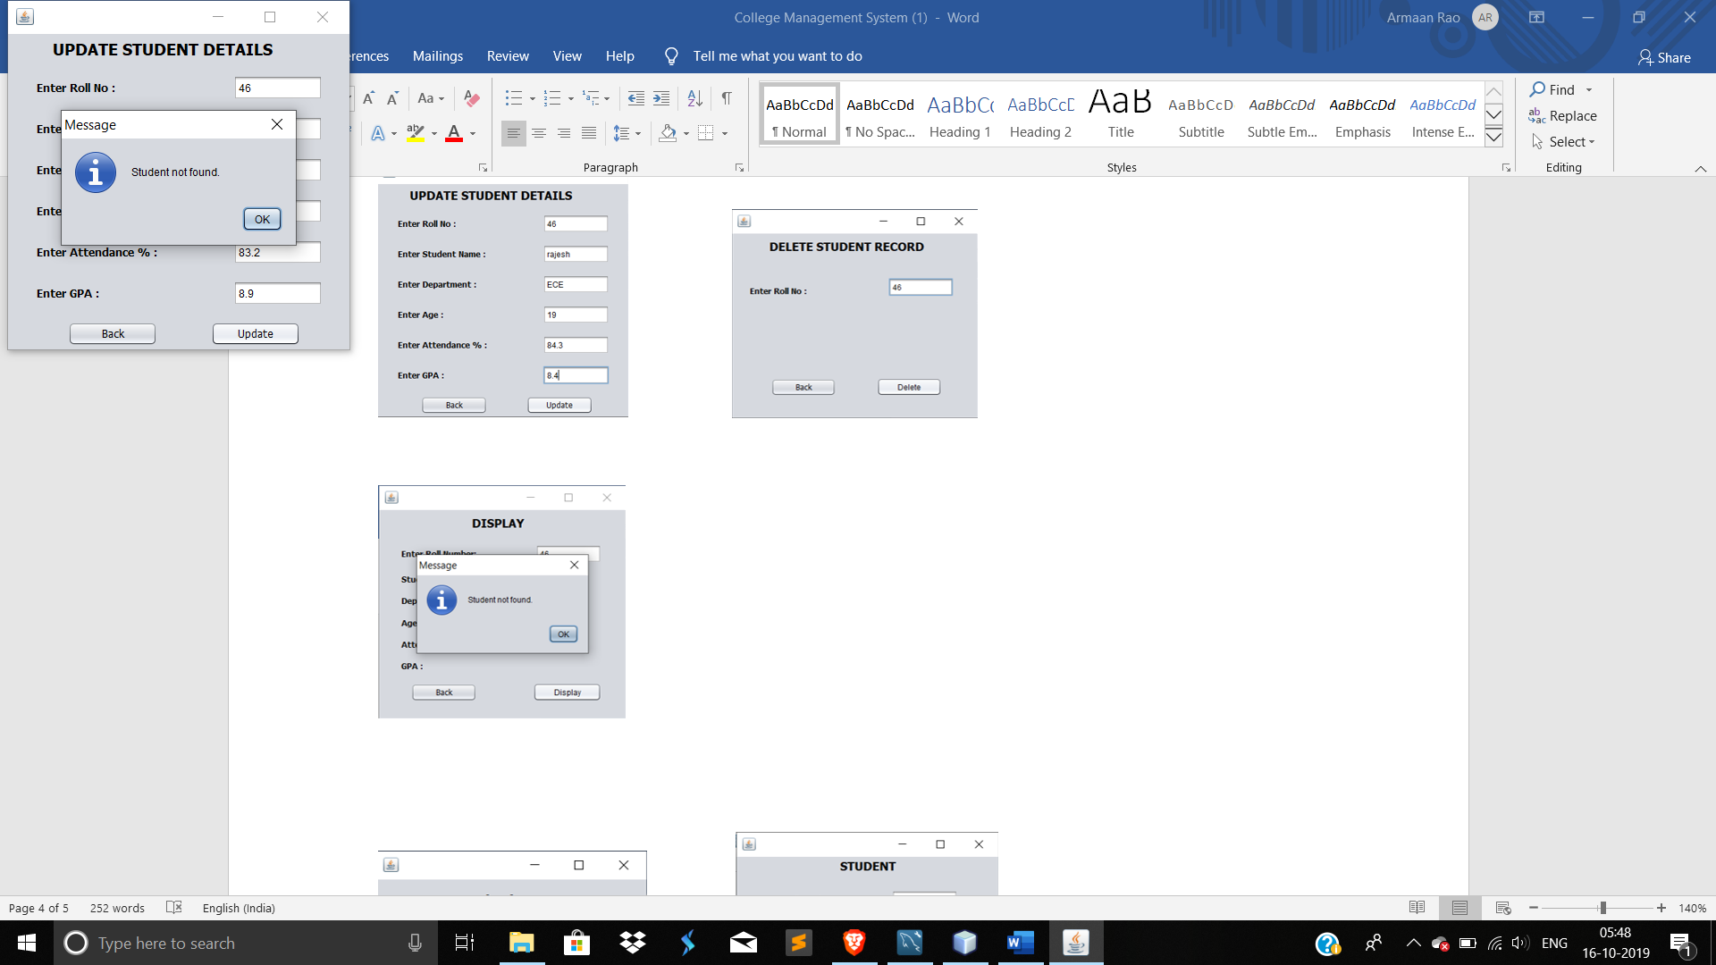 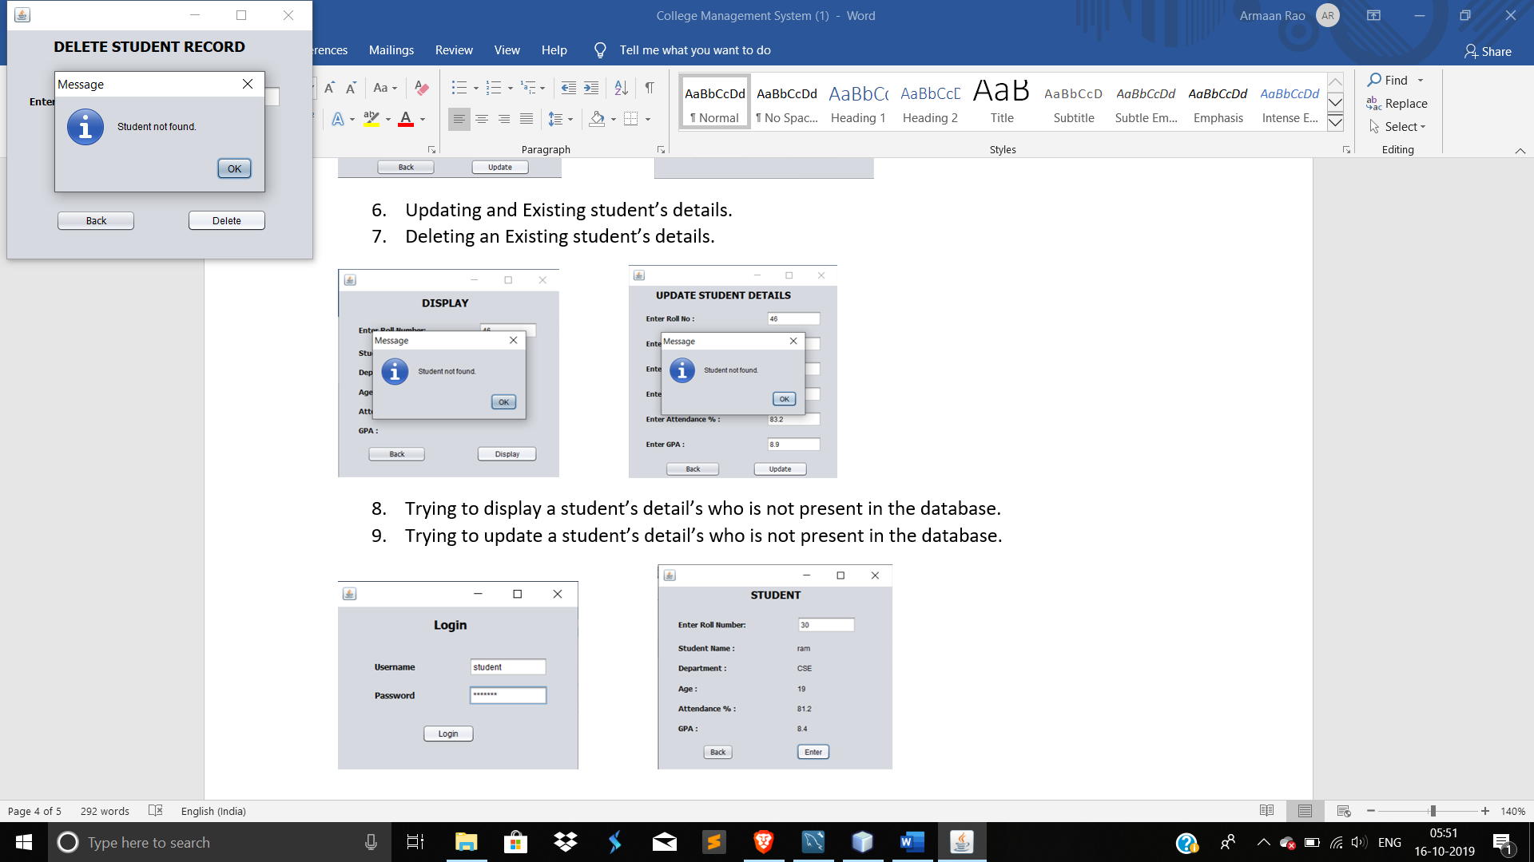

1. Trying to display a student’s detail’s who is not present in the database.
2. Trying to update a student’s detail’s who is not present in the database.
3. Trying to delete a student’s detail’s who is not present in the database.

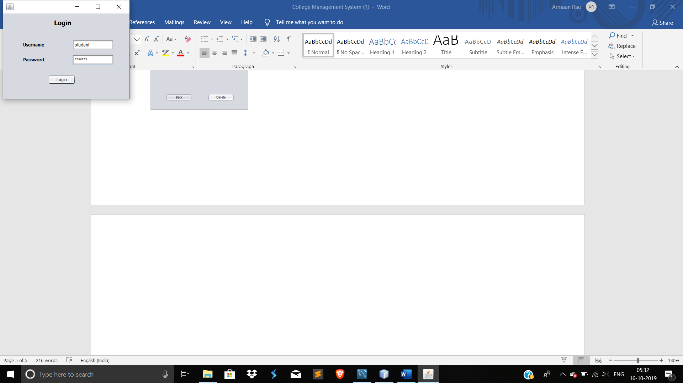 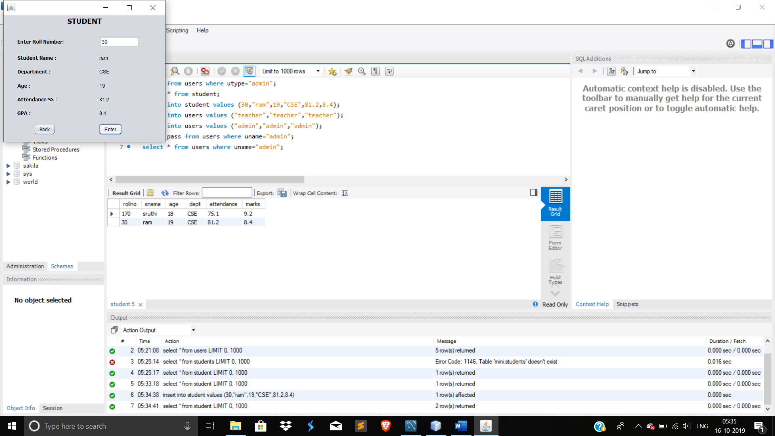

1. Loging in as a student.
2. A student can the view student details from the database by entering roll number.

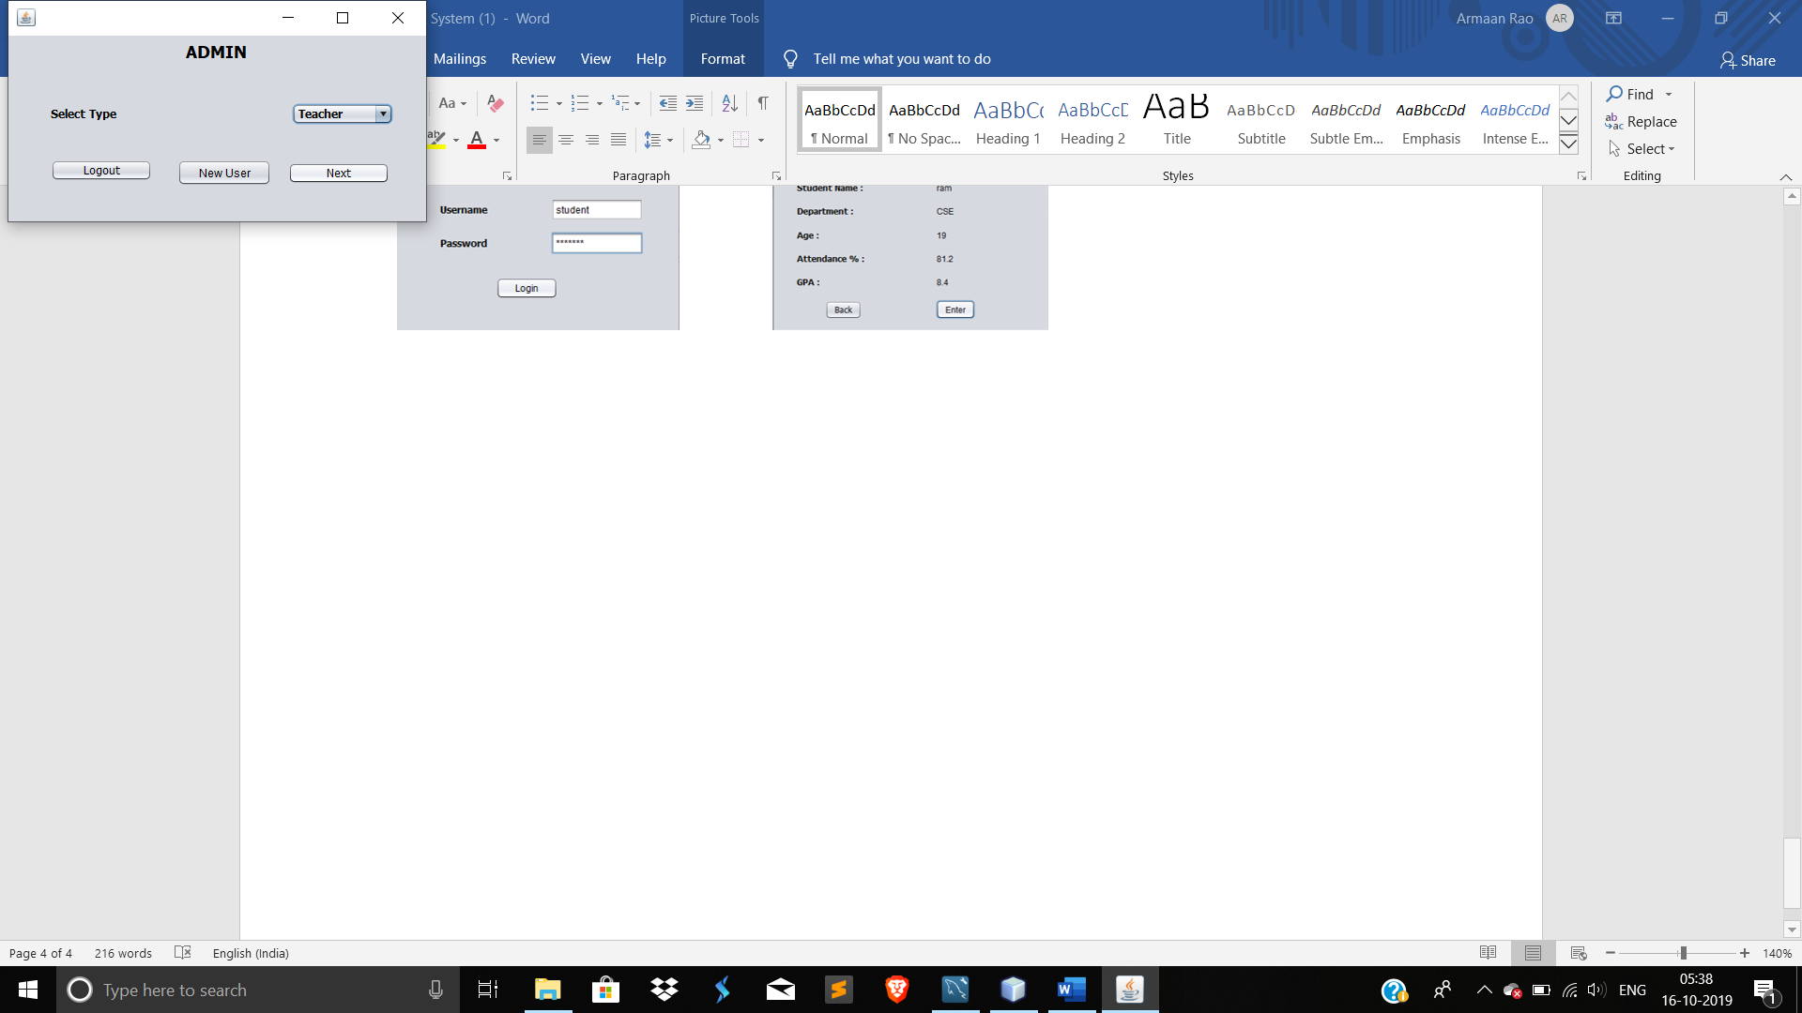 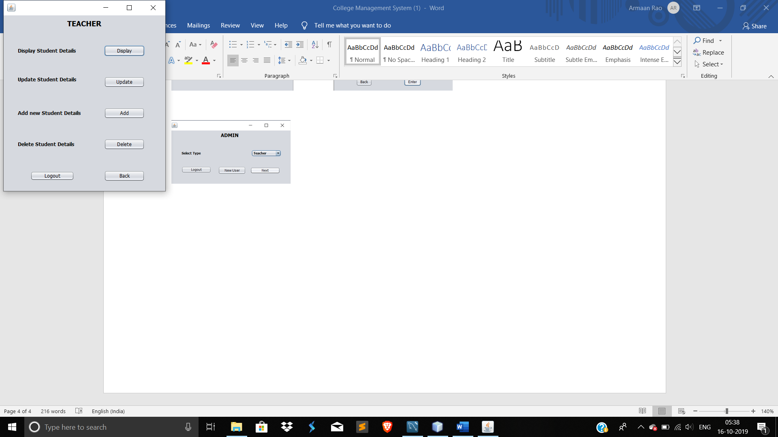

1. Using an admin account to access the system as a teacher.

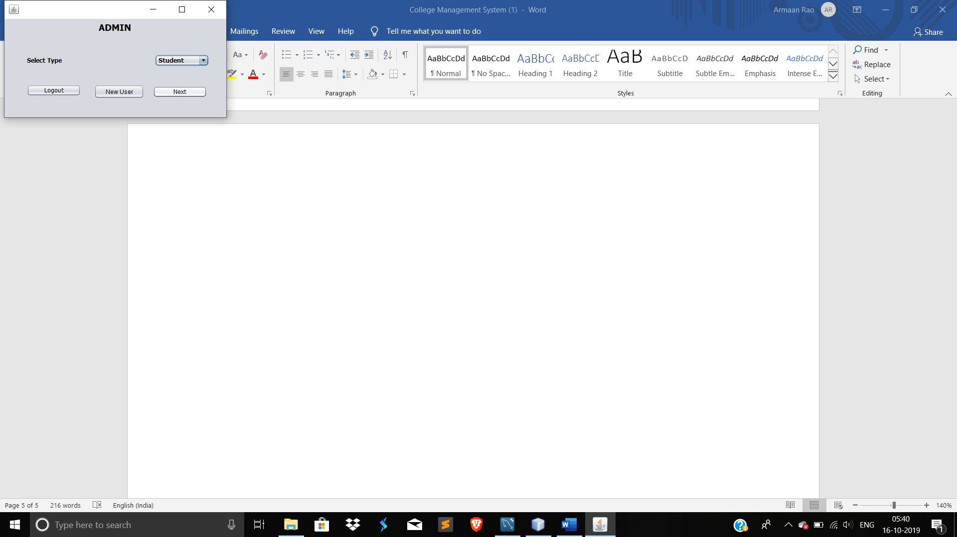 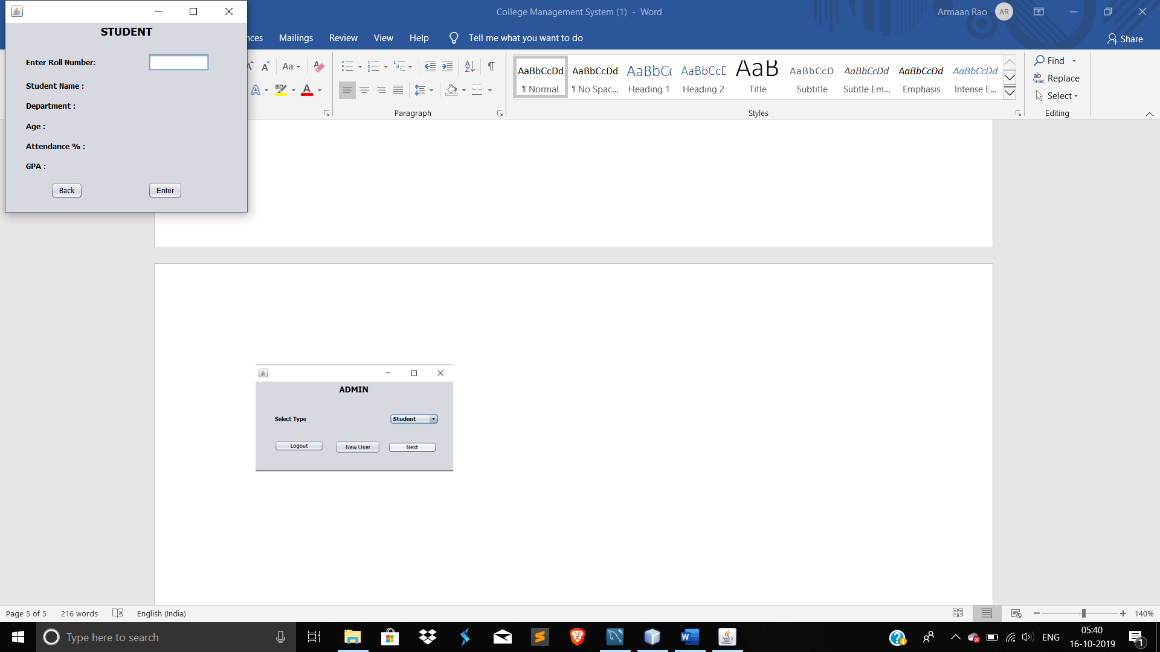

1. Using an admin account to access the system as a student.